Assignment 1 – (Hello World, etc)

Below is the screenshot of 2 test cases passed along with date and time:

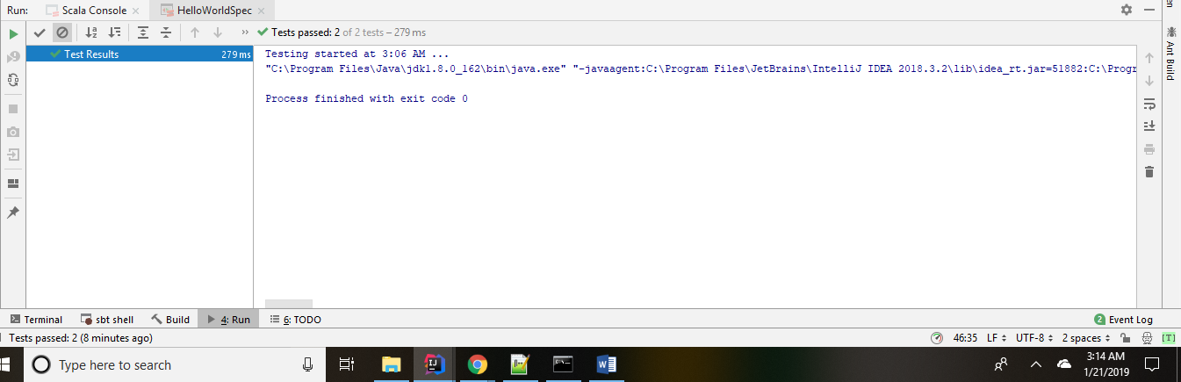

Below is the screenshot of the code which I changed:

As per the instructions, I replaced line 38 with the code provided in assignment.

Below is the screenshot of code run along with date and time:

Hello world program execution:

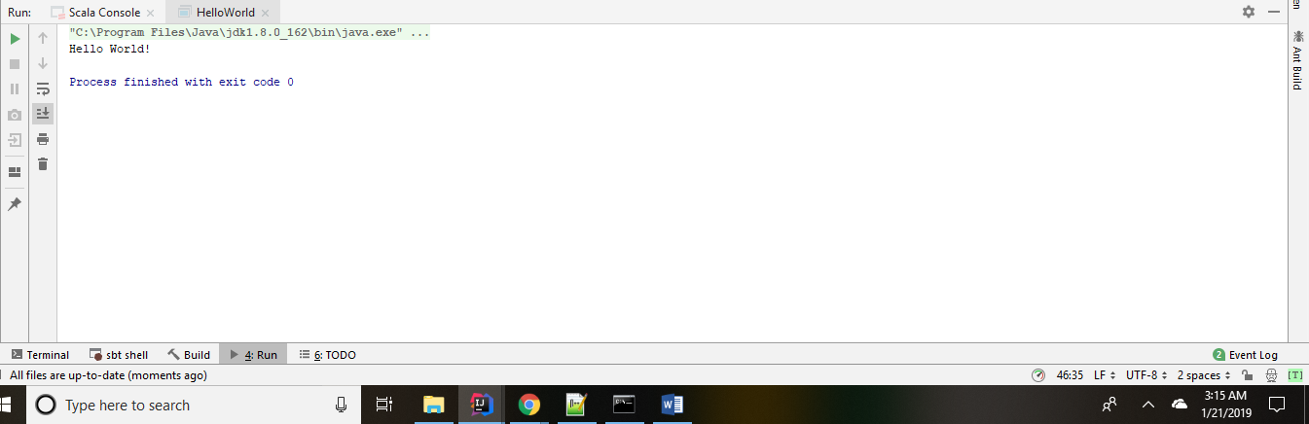

Ingest program execution:

